**BAR COUNCIL OF THE STATE OF TELANGANA::HYDERABAD**

APPLICATION SEEKING SUBSISTENCE ALLOWANCE IN THE WAKE OF COVID -19 LOCKDOWN

(Application to be forwarded through Bar Association)

AT FIRST INSTANCE ADVOCATESENROLLED FROM 01.01.2015 ARE ELIGIBLE TO FILE APPLICATIONS

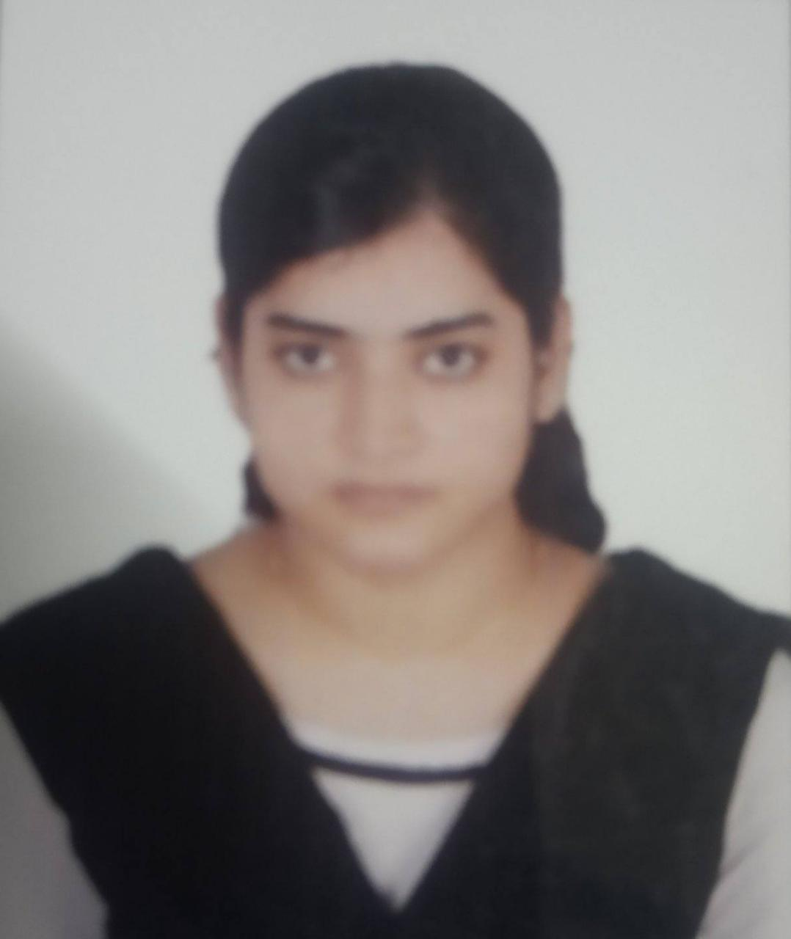

Photo

in

robes

|  |  |  |  |
| --- | --- | --- | --- |
| 1. Name (in Block Letters) |  | : | _____SYEDA ADBIBA FATHIMA__________ |
| 1. Father’s Name |  | : | _____SYED HUSSAIL KAZIM____________ |
| 1. Date of Birth& Age |  | : | _____01/03/1996________________________ |
| 1. Enrolment No. |  | : | _____TS/1281/2019______________________ |
| 1. Date of Enrolment |  | : | _____22/08/2019________________________ |
| 1. Contact Number |  | : | _____7396330376_______________________ |
| 1. Email ID |  | : | _____syedadibafatima@gmail.com________ |
| 1. Place of practice |  | : | _____HYDERABAD |
| 1. Whether COP Application filed |  | : | Yes / No (NO) |
| 1. Address 2. Permanent 3. Temporary |  | :  : | _____________________________________  H.NO.1-7-457/A/B2 Musheerabad,Hyderabad  H.NO.1-7-457/A/B2 Musheerabad,Hyderabad |
| 1. Accommodation : |  | : | Own / Rented (RENTED) |
| 1. Whether Income Tax assessee |  | : | Yes / No (NO) |
| 1. Whether own a four wheeler |  | : | Yes / No (NO) |
| 1. Marital status |  | : | Yes / No (NO) |
| 1. Whether spouse employee |  | : | Yes / No (NO) |
| 1. Whether applicant is in receipt of any aid either from Central/ State Governments under COVID-19 |  | : | Yes / No (NO) |

1. Cgcnb Bank Account Details
2. Account No. : 3704267169
3. Name of the bank and branch: Central bank of india ,Rein Bazar
4. IFSC Code : CBIN0281475

DECLARATION

I _____Syeda Adiba Fatima_________________ hereby solemnly declare that the above information furnished by me is true and correct and I have not suppressed any material facts before the Bar Council of the State of Telangana. If the council found any information is false, the same can be treated as misconduct and necessary proceedings can be initiated as per the Advocates Act, 1961.

Date: 06-04-2020 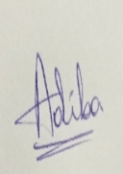

Place: Hyderabad Signature

Note: Extraordinary arrangement is made only for advocates, who are unable to meet their day

to day expenses and food or even medicines and request from only such advocates will

be entertained. Advocates enrolled after retirement from any service are not eligible.